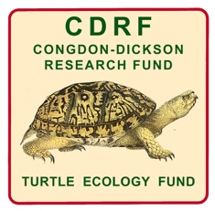

The Justin Congdon and Nancy Dickson Research Fund (CDRF)
(Turtle Ecology Fund)
at Chelonian Research Foundation (CRF)

PROPOSAL COVER SHEET
(This cover sheet must accompany the proposal)

Project Title:

Name(s) of Principal Investigator(s) and their Institutional Affiliation(s):

Total Project Budget $
Funding Requested Specifically from CDRF for this Project $
Funding Requested from Other Sources for this Project
(list sources and amounts separately) Granted?
__________________________________ $_____________ _____
__________________________________ $_____________ _____
__________________________________ $_____________ _____

Total Funding Already Granted from All Sources for this Project $_____________
Total Funding Still Pending from All Sources for this Project $_____________

List the principal turtle species covered by your project.

Geographic location(s) of your project:

If your project involves an existing or proposed Protected Area (National Park, Wildlife Reserve, etc.), please list here:

• By submitting this application, and if funded, the proponents declare that all permits required to carry out the proposed project will be obtained as necessary, and that no work on the project will be commenced without the required permits.

• Further, the proponents declare that they and their project collaborators will not collect, obtain, or distribute any turtles or other wildlife, whether live animals, parts or derivatives, for possession, transport, export, import, or sale, in breach of applicable national and international laws and regulations, during any phase of the supported project.

Principal Lead Investigator:
Name:______________________________________
Address:_____________________________________
E-Mail:_____________________________________
Phone:_________________________________

Executive Summary (less than 400 words, shorter is better),

Introduction

Objectives and Hypotheses

Methods (Be Specific)

Expected Significance

Budget and Timeline

Literature Cited

C.V.(s) of Principal Investigator(s)
(Attach or send separately)

